Standard Unit Specifications
● Jamb: Primed Pine, 5/4” x Various
● Trim: WM180 Brick Moulding, 1-1/4” x 2”
● Sill Threshold: Fixed Aluminum, Thermal Break
● Bore: 2-1/8” Face, 2-3/8” Backset
● Hinges: 4” Zinc Dichromate (3/door)
● Weatherstrip: Foam Compression
● Sweep: 4 Fin Vinyl
● Handing: Must Specify Left or Right

Door Handing Guide
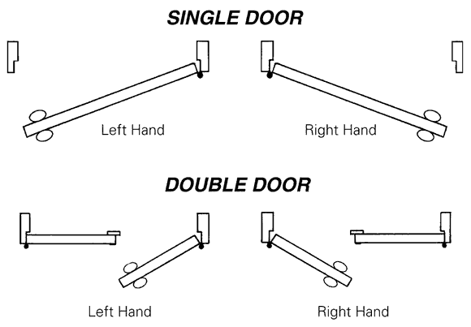
● When the door opens toward you and the knob is on the LEFT it is a LEFT HAND opening
● When the door opens toward you and the knob is on the RIGHT it is a RIGHT HAND opening
This description of handing applies to all the door units we build, both inswing and outswing.

Unit Pricing
Base | Price of standard unit (frame only) | Page A2
+ | Add cost of door(s) | Section B
+ | Add cost of sidelight(s) | Page A4
+ | Add cost of transom sash & frame | Page A5
+ | Add cost of multipoint lock | Page A6
+/- | Adjust price for options | Page A3
= | Total Unit List Price

EDU/DEDU
Standard Door Units - Frame Only - Add Components
See Page A1 for Standard Specifications, Handing, and Unit Pricing information

 |  |  |  | Frame
 | Style A – Single |  |  | FJ | S | 514S | 6916S | 6916FJ
 | Door Size |  | Rough Opening | 4-9/16”  Fingerjoint | 4-9/16”  Solid | 5-1/4”  Solid | 6-9/16”  Solid | 6-9/16”  Fingerjoint
 | 2’8” x 6’8” |  | 2’10-5/8” x 6’11” | 155.80 | 237.00 | 287.80 | 317.20 | 192.20
 | 3’0” x 6’8” |  | 3’2-5/8” x 6’11” | 157.70 | 238.90 | 289.70 | 319.10 | 194.10
 | 3’0” x 7’0” |  | 3’2-5/8” x 7’3” |  | 239.20
Includes weather-stripped T-astragal | Style B – Double |  |  | FJBH | SBH | 514SBH | 6916SBH | 6916FJBH
 | Door Size |  | Rough Opening | 4-9/16”  Fingerjoint | 4-9/16”  Solid | 5-1/4”  Solid | 6-9/16”  Solid | 6-9/16”  Fingerjoint
 | 5’0” x 6’8” |  | 5’3-3/8” x 6’11”* | 329.80 | 427.20 | 492.70 | 534.90 | 384.90
 | 5’4” x 6’8” |  | 5’7-3/8” x 6’11”* | 329.80 | 427.20 | 492.70 | 534.90 | 384.90
 | 6’0” x 6’8” |  | 6’3-3/8” x 6’11”* | 329.80 | 427.20 | 492.70 | 534.90 | 384.90
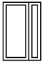 | Style C - 1 Sidelight |  |  | 1FJ | 1S | 1514S | 16916S | 16916FJ
 | Door Size |  | Rough Opening | 4-9/16”  Fingerjoint | 4-9/16”  Solid | 5-1/4”  Solid | 6-9/16”  Solid | 6-9/16”  Fingerjoint
 | 3’0” x 6’8” |  | 4’4-1/4” x 6’11”** | 354.70 | 499.00 | 567.70 | 646.40 | 414.40
 |  |  |  | Frame is same price with 10”, 12”, or 14” sidelight
Specify sidelight Left or Right, from the outside looking in
(.SLLJ - SDLT Lock Jamb, .SLHJ - SDLT Hinge Jamb)
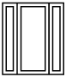 | Style D – 2 Sidelights |  |  | 2FJ | 2S | 2514S | 26916S | 26916FJ
 | Door Size | Rough Opening |  | 4-9/16”  Fingerjoint | 4-9/16”  Solid | 5-1/4”  Solid | 6-9/16”  Solid | 6-9/16”  Fingerjoint
 | 3’0” x 6’8” | 5’5-3/4” x 6’11”** |  | 494.00 | 696.80 | 824.10 | 913.90 | 575.40
 |  |  |  | Frame is same price with 10”, 12”, or 14” sidelights

*Rough opening includes weather-stripped T-astragal with flush bolts
For a plain T-astragal, deduct 3/8” from rough opening width

**Rough opening includes 12” sidelights
For each 10” sidelight, deduct 2” from rough opening width
For each 14” sidelight, add 2” to rough opening width

EDU/DEDU
Door Unit Options
See Page A1 for Standard Specifications, Handing, and Unit Pricing information

Extension Jambs (built up)
For this jamb | Add to this Standard Unit | Singles* | Doubles
9-5/8” FJ Jamb | 4-9/16” FJ Jamb | 96.90 | 121.00
9-5/8” Solid Jamb | 6-9/16” Solid Jamb | 55.00 | 56.20
14” Solid Jamb | 6-9/16” Solid Jamb | 111.20 | 123.00
Intermediate size – rip charge (RDJE) |  | 10.00 | 10.00
*Add an additional ‘Singles’ charge for each installed sidelight or transom

Additions to Standard Door Unit |  | Singles | Doubles
Alternate Trim | Primed FJ Square Edge Casing 1”x3-1/2” (FJSEC) | 28.90 | 38.60
Size Options | Oversize Single Unit 3’0” to 4’0” Wide | 25% to 3’0” | —
 | Cut Down Flush Door Height *voids warranty* (CD) | 55.55 | 111.10
 | Spread Mull, each, up to 6” | 55.55 | 55.55
Labor/Prep Options | Deadbolt Bore (DB1, DB2) | 8.00 | 8.00
 | 2-3/4” Backset (234) | 8.00 | 8.00
 | Peep Sight Bore (PHOLE) | 8.00 | 8.00
 | Hang Customer’s Door *subject to approval* | 100.00 | 200.00
Sill Options | Outswing (includes NRP hinge) | 8.75 | 28.90
 | Bronze Oak Adjustable | 22.70 | 44.90
 | Aluminum Oak Adjustable | 10.70 | 22.00
 | Long Sill Horns | 28.00 | 28.00
Hinge Options | 4”x4” Solid Brass (3SBHE, 3SBHEBH) | 50.00 | 100.00
 | 4”x4” Bright Brass Plated (3BBHE, 3BBHEBH) | 6.00 | 12.00
 | 4”x4” #26D Dull Chrome (326DHE, 326DHEBH) | 6.00 | 12.00

Deductions From Standard Door Unit |  | Singles | Doubles
Standard Unit Less: | Threshold Sill (NSS, NDS) | (24.00) | (46.50)
 | Weatherstrip (NWS, NWSBH) | (4.00) | (6.20)
 | FJ Brick Moulding (NFJB) | (21.70) | (26.00)
 | Solid Brick Moulding (NSB) | (44.30) | (53.10)
 | Weather-stripped T-astragal (NT) | — | (85.90)

Other Components
Exterior Wood Doors | Section B
Sidelights | Page A4
Transoms | Page A5
Multipoint Locks | Page A6

1 Light | 1 Light  1 Raised Panel | 3 Light  1 Raised Panel | 5 Light

HSL/HTR
Pine Sidelights

Description | Size | Item # | List
1 Light IG | 10” x 1-3/8” | 101I* | 271.16
1 Light IG | 12” x 1-3/8” | 121I | 275.16
1 Light IG | 14” x 1-3/8” | 141I* | 311.02
1 Light IG / Raised Panel | 10” x 1-3/8” | 101PI | 271.16
1 Light IG / Raised Panel | 12” x 1-3/8” | 121PI | 275.16
5 Light IG True Divided Light | 12” x 1-3/8” | 125DVI* | 275.16
5 Light Single Glazed | 12” x 1-3/8” | 125T | 195.40
Pine Grille Bars
Grille Bar with Clips for 10” Sidelight |  | 10BAR | 3.50
Grille Bar with Clips for 12” Sidelight |  | 12BAR8 | 3.50
*non-stock item

DFE/GR
“Energy Guard” Fir Sidelights

Description | Size | Item # | List
1 Light IG (9-3/4” Bottom Rail) | 12” x 1-3/4” | EG4701 | 285.94
1 Light IG / Raised Panel | 12” x 1-3/4” | EG4702 | 303.92
3 Light IG True Divided Light / Raised Panel | 12” x 1-3/4” | EG4703 | 319.00
5 Light IG True Divided Light | 12” x 1-3/4” | EG4705 | 341.04
Full Surround Fir Grilles
3 Light Grille for 1 LT/RP (EG4702) |  | GB103 | 37.08
5 Light Grille for 1 LT (EG4701) |  | GB105 | 46.92

HTR

1-3/8” Pine Transom Glazed with 7/16” Insulated Glass

 |  | 10” Height |  | 12” Height |  | 12” Height GBG
Door Size | Sash Width | Item # | List | Item # | List | Item # | List
2’8” | 32” | 3210 | 87.16 | 3212 | 87.16 | 3212 GBG | 98.00
3’0” | 36” | 3610 | 93.90 | 3612 | 93.90 | 3612 GBG | 104.74
4’0” | 48” | Special | Please call | 4812 | 113.68 | Special | Please call
5’0” | 60-1/2” | 6010 | 156.78 | 6012 | 156.78 | 6012 GBG | 172.66
1’0”/3’0”/1’0” | 63-1/2” | 6310 | 157.74 | 6312 | 157.74 | 6312 GBG | 177.74
5’4” | 64-1/2” | 6410 | 157.74 | N/A | — | N/A | —
1’2”/3’0”/1’2” | 67-1/2” | Special | Please call | 6712 | 157.74 | 6712 GBG | 189.00
6’0” | 72-1/2” | 7210 | 181.36 | 7212 | 181.36 | 7212 GBG | 203.40
6’0” HPD | 73-1/2” | 7310 | 181.36 | Special | Please call | N/A | —
Grille Bars
10” division bar (5-7/8” O.A.) |  |  | 10BAR | 3.50
12” division bar (8” O.A.) |  |  | 12BAR8 | 3.50

Transom Sash Installed in a Unit
Add Sash Price and Framing Charge to Standard Unit List

Framing Charge
4-9/16” FJ Jamb | 135.30
4-9/16” Solid Jamb | 212.10
6-9/16” FJ Jamb | 167.10
6-9/16” Solid Jamb | 295.80

HAR
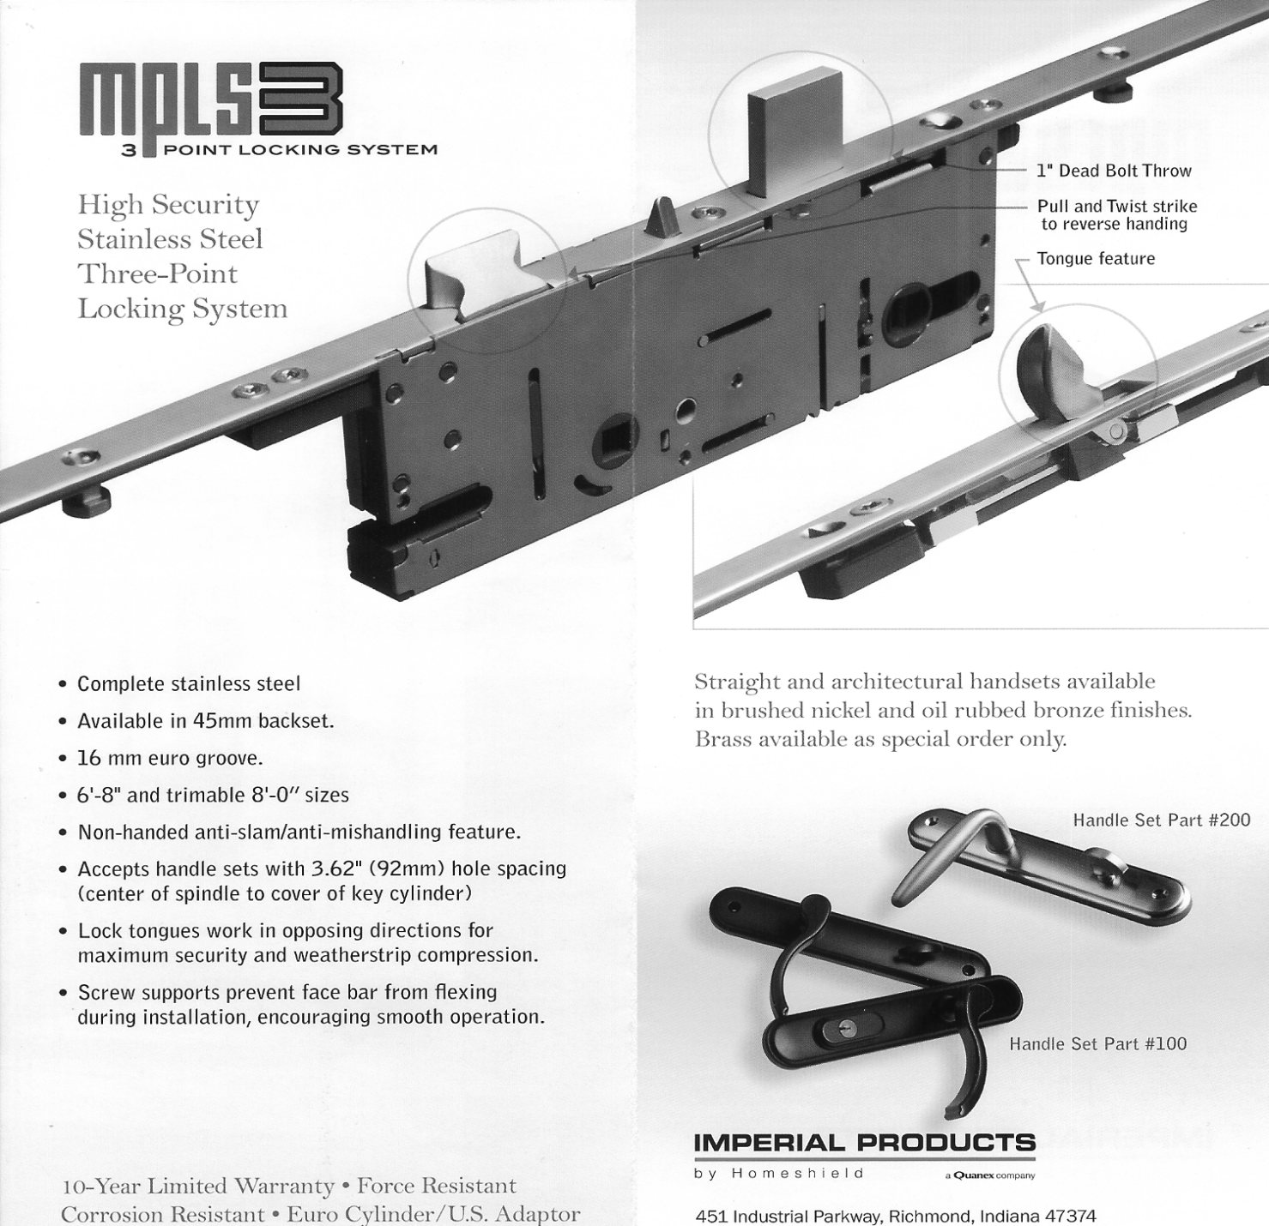

Description | Item # |  | List
Construction Handle | CHANDLE |  | 16.58
Latch Assembly 6’8” Height | MPLS68LATCH |  | 259.76
Latch Assembly 8’0” Height | MPLS80LATCH |  | 294.94
Lock Trim Regency LH Brushed Nickel | MPLSTRIMLHBN |  | 278.68
Lock Trim Regency RH Brushed Nickel | MPLSTRIMRHBN |  | 278.68
Lock Trim Regency LH Oil Rubbed Bronze | MPLSTRIMLHORB |  | 278.68
Lock Trim Regency RH Oil Rubbed Bronze | MPLSTRIMRHORB |  | 278.68
JBEX
Exterior Door Frames - Knocked Down
5/4” Rabbeted Jambs ● 1-1/4 x 2” Brick Moulding ● No Sill

Door Size | 4-9/16” Solid | 4-9/16” FJ | 5-1/4” Solid | 6-9/16” Solid | 6-9/16” FJ
2’8” x 6’8” | 149.60  (28458SSET) | 70.80  (28458FJSET) | — | — | —
3’0” x 6’8” | 149.60  (30458SSET) | 70.80  (30458FJSET) | 188.40  (30514SSET) | 211.60  (306916SSET) | —
3’0” x 7’0” | 151.96  (307456SSET) | — | — | — | —
6’8” Side Jambs Only | 82.20/pair | 36.90/pair | — | 136.10/pair | 56.90/pair

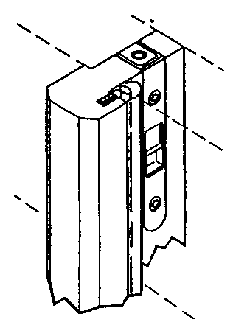
T-Astragals

Size | Description | Item # | List
6’8”, 1-3/4” | Weather-stripped w/ Flush Bolts | 68TAEQ | 89.76
7’0”, 1-3/4” | Weather-stripped w/ Flush Bolts | 70TAEQ | 91.34

Compression Weatherstrip Set | Single Door | 7.00
 | Double Door | 10.50

Vinyl Door Sweep (4 fin, brown) | 2’8” Width | 4.90
 | 3’0” Width | 4.90

JBEX
Aluminum Threshold Sills
● 4-5/8” with 2” horns
● Thermal Break

 | Inswing - Adjustable  Oak Riser |  | Inswing - Fixed |  | Outswing - Fixed
Size | Item # | List | Item # | List | Item # | List
2’8” (32-3/16”) | 32OAKADJ | 32.10 | 32A112 | 22.32 | 321600458 | 30.70
3’0” (36-3/16”) | 36OAKADJ | 34.02 | 36A112 | 23.64 | 361600458 | 32.82
6’0” (73-1/8”) | 72OAKADJ | 66.58 | 72A112 | 46.06 | 721600458 | 74.56
2” Extender for 3’0” |  |  | EE36 | 10.20
2” Extender for 6’0” |  |  | A112C | 23.34

SILLPAN
Door Sill Pans

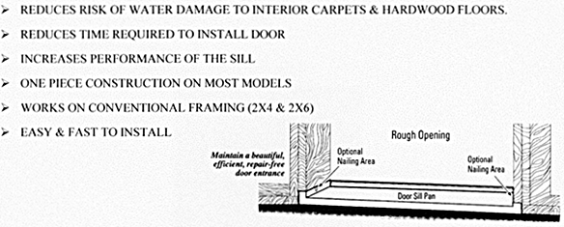
Less 5% on full cartons
2’8” & 3’0” | 20 per carton
All others | 10 per carton

 |  | 4-9/16” Jamb |  | 6-9/16” Jamb
Size | Unit | Item # | List | Item # | List
33-3/4” | 2’8” Single | SP33754 | 15.92 | SP33756 | 19.80
37-3/4” | 3’0” Single | SP37754 | 17.20 | SP37756 | 21.38
50-1/4” | 4’0” Bihung | SP5025C4 | 19.42 | SP5025C6 | 24.28
62-1/4” | 5’0” Bihung | SP62254 | 20.54
66-1/4” | 5’4” Bihung | SP66254 | 21.10 | SP66256 | 27.94
74-1/4” | 6’0” Bihung | SP74254 | 22.94 | SP74256 | 29.24
63-1/4” | 5’0” Patio | SP6325C4 | 22.16
64-3/4” | 1’0”/3’0”/1’0” | SP6475C4 | 22.16 | SP6475C6 | 29.34
72” | Adjustable  w/ sealant | SPADJ4 | 47.48 | SPADJ6 | 58.34

NOVA
Imagine Series
DP 50 Sliding Door

5-7/8” Frame Width - can be installed in 4-9/16” or 6-9/16” wall

Size | Screen  Type | Clear  w/ Low-E | 15 Light GBG  w/ Low-E | Clear  w/ Tilt Blinds | Clear w/ Raise-  Lower Blinds
5’0” x 6’8” | Sliding | 1683.46 | 1785.46 | 1,617.92* | 2025.16
5’0” x 6’8” | Retractable | 1780.36 | 1882.46 | — | —
6’0” x 6’8” | Sliding | 1775.26 | 1877.26 | — | 2116.96
6’0” x 6’8” | Retractable | 1872.16 | 1974.16 | — | —
*Discontinued - subject to inventory on hand

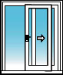 | 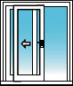
OF = Operating left  Fixed right  (XO) | FO = Fixed left  Operating right  (OX)
Rough Opening | Overall Dimensions
5’0” x 6’8” | 59-1/4” x 79-1/2”
6’0” x 6’8” | 71-1/4” x 79-1/2”

DP 50 single and double swinging patio doors are also available, by special order

QUANTITY DISCOUNTS FOR SAME SIZE AND KIND DROP SHIPMENT

5 DOORS LESS 5%
10 DOORS LESS 8%

For larger quantities or mixed quantities call for quote

SHOWROOM DISPLAYS AVAILABLE
Free after purchase of 10 doors

